Walchand College of Engineering, Sangli

Department of Computer Science and Engineering

Third Year – Programming Laboratory-3 (2020-21)

PRN : 2018BTECS00026

Github link : <https://github.com/rohitopal/PL3-assignments/tree/master/PL-3%20Practical%20No.%205B%20-%20T2>

Practical No. 5B (Batch – T2) To design and develop web pages using HTML fundamental and formatting elements

1.Design and develop a static web page using HTML for Astronomy blog. Access it locally and in LAN using web server

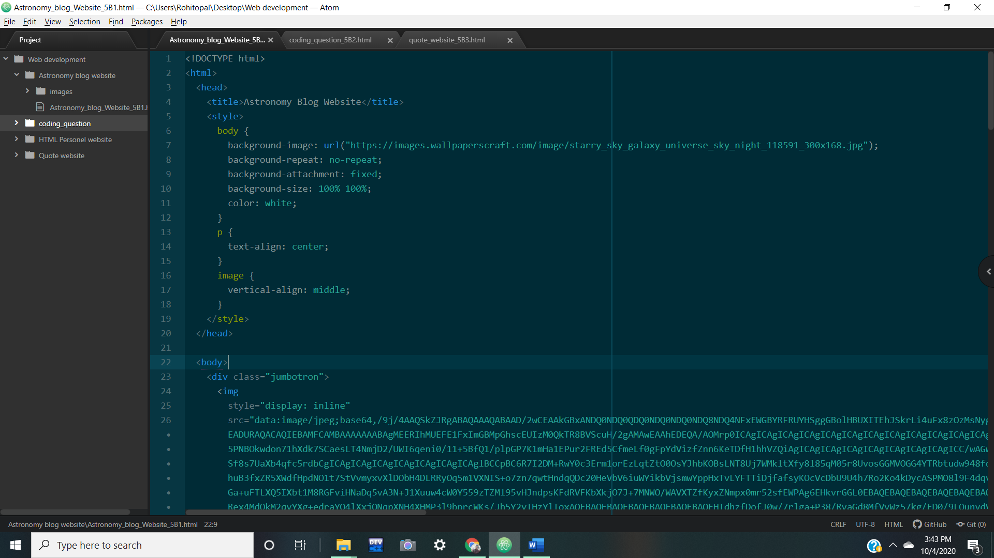

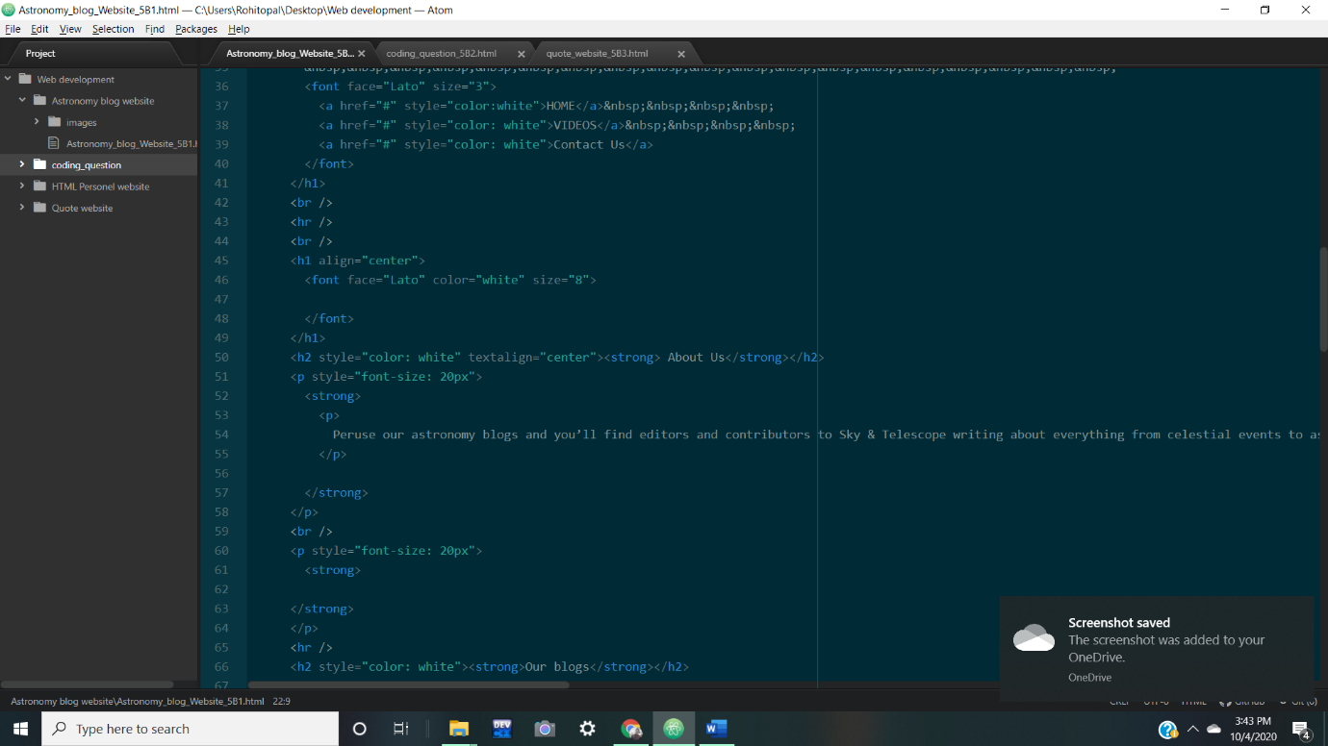

Webpage:

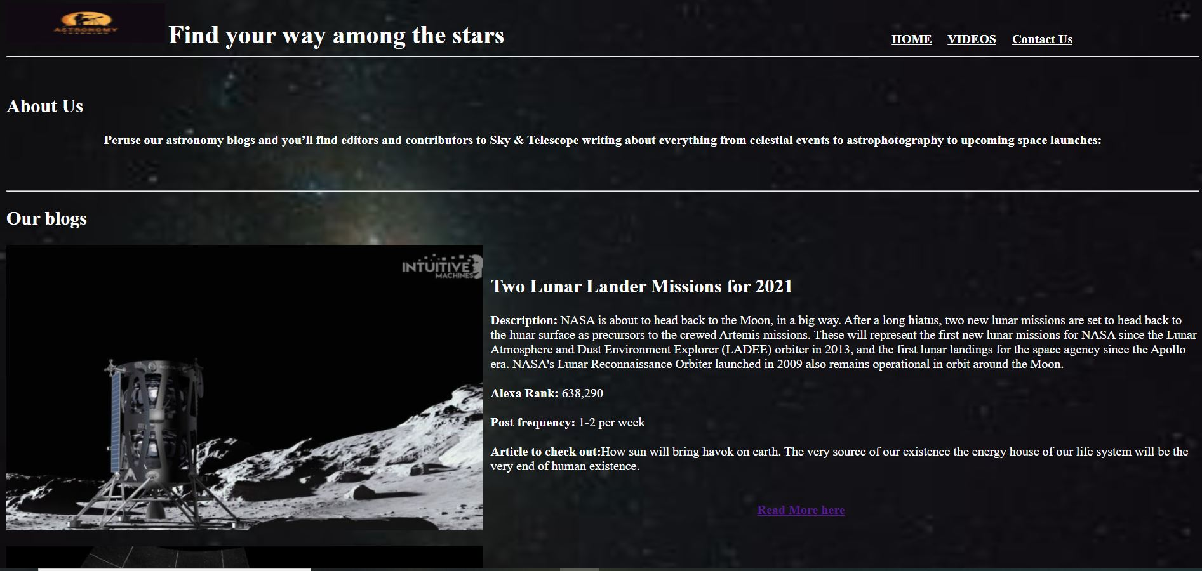

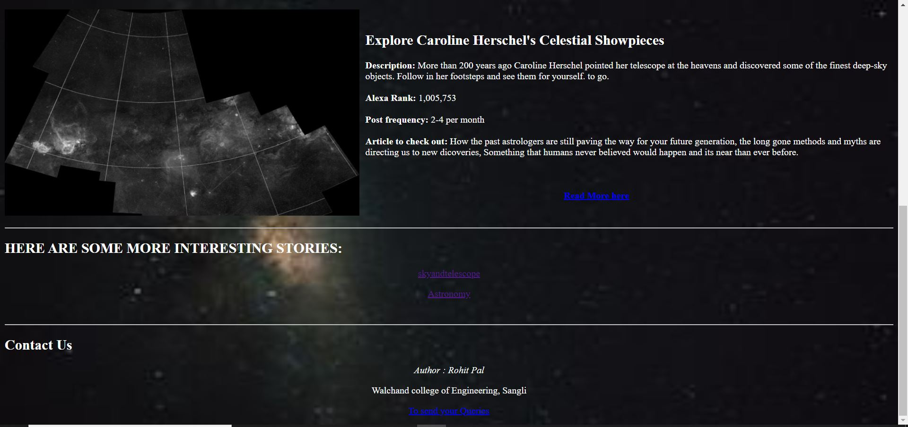

2. Problem Statement: Write a program in any language to read 10 numbers from keyboard and find their sum and average.

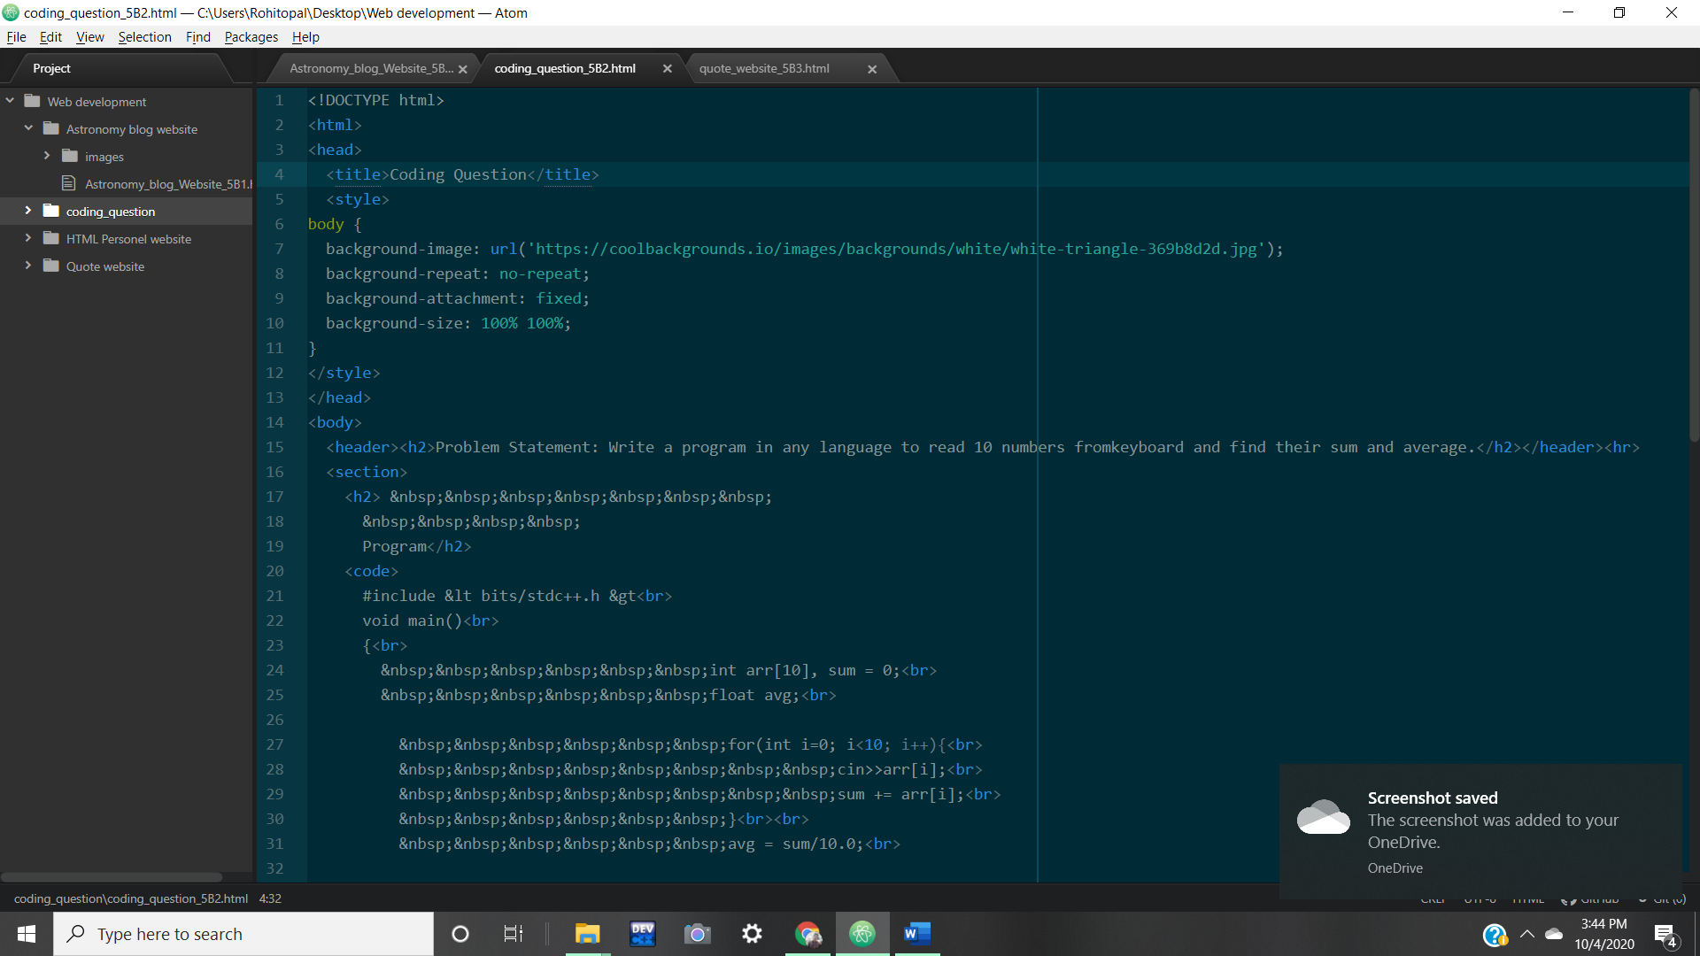

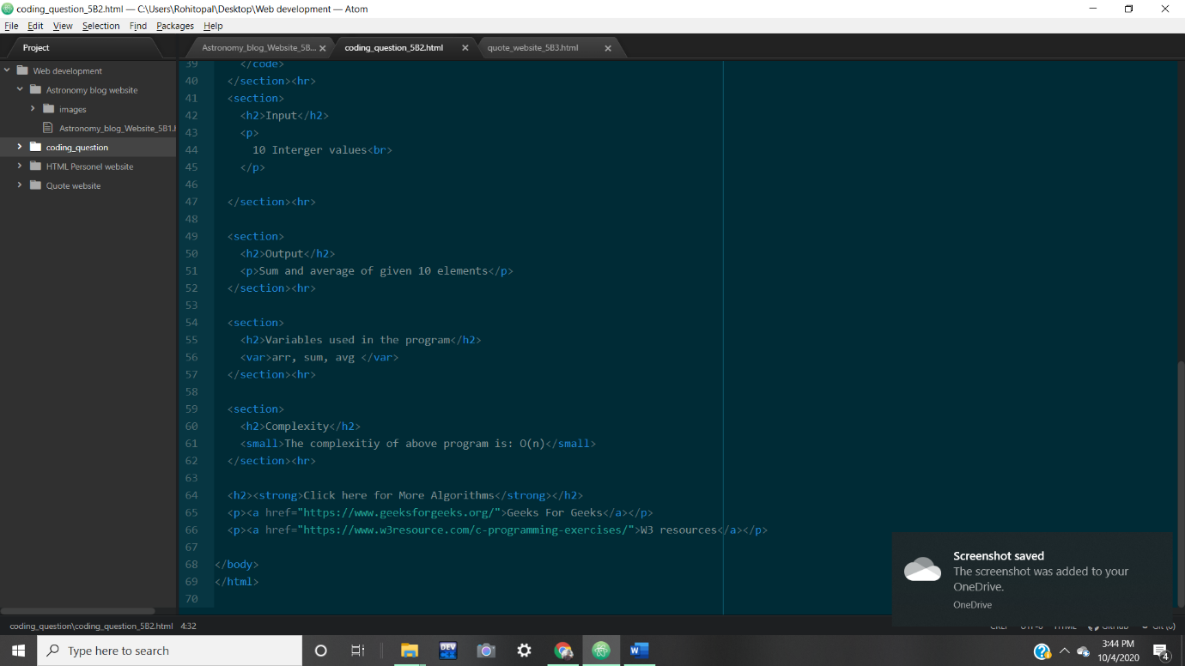

Webpage:

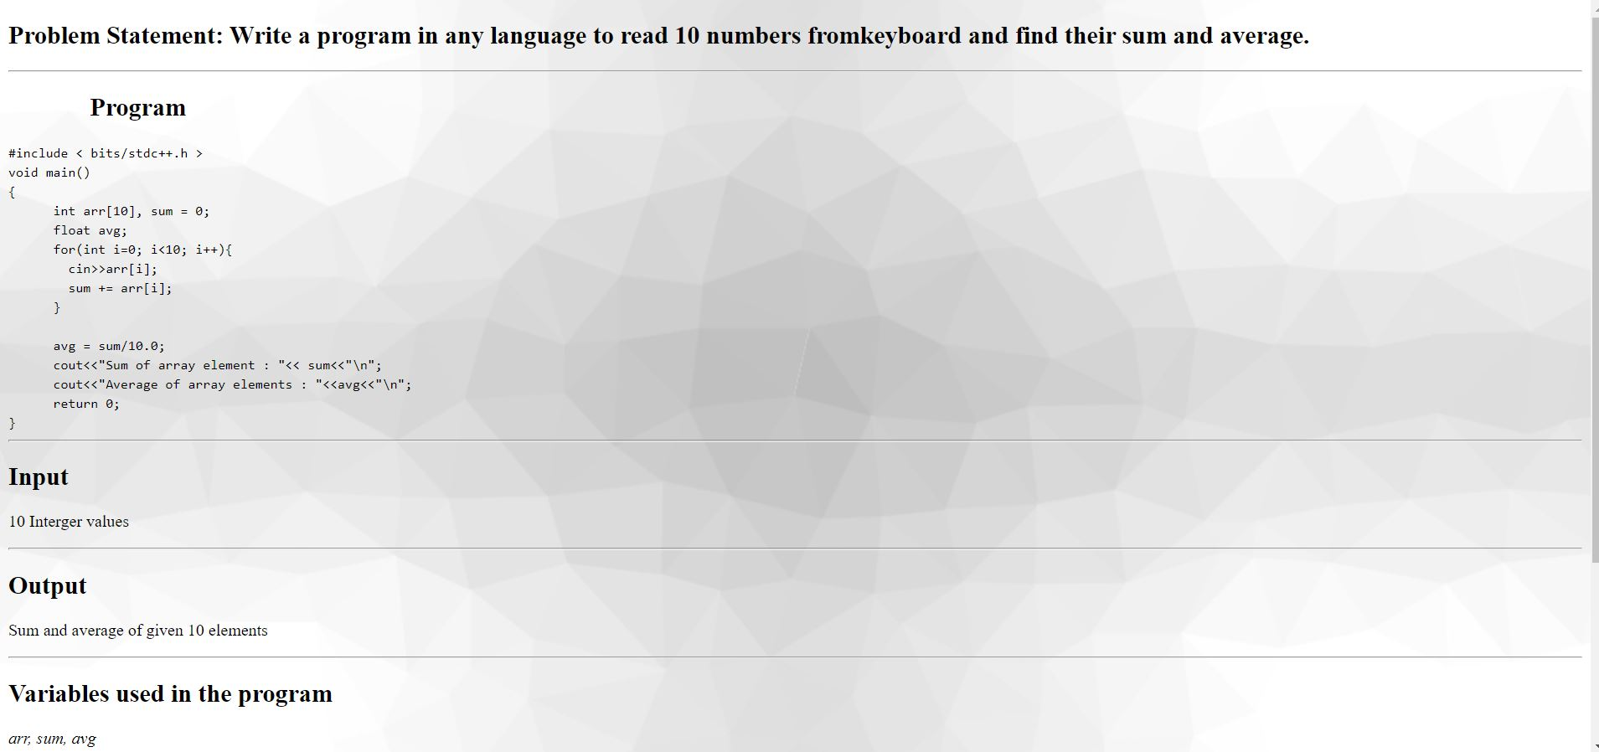

3. Any three quotes from https://www.brainyquote.com/ with the name of person who quoted it

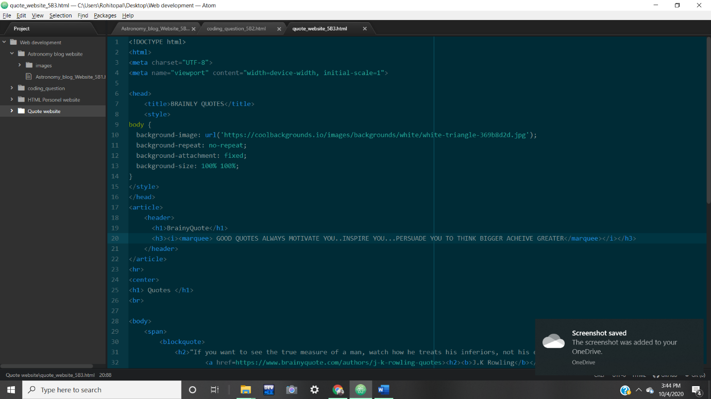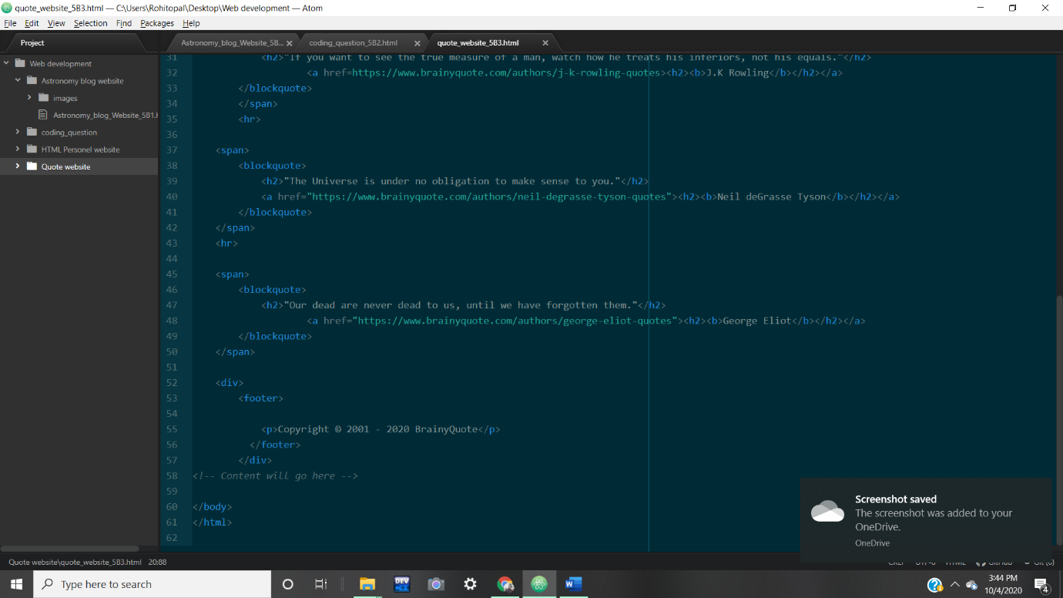

Webpage :

